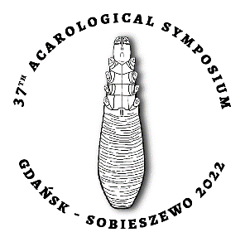
XXXVII Acarological Symposium
8-11 June 2022
Gdańsk-Sobieszewo

Participation Registration

First name and last name: …………………………………………………………………………………………………………………………

Academic degree and title: ………………………………………………………………………………………………………………….......

Affiliation and address: ……………………………………………….…………………………………………………………………………….

………………………………………………………………………………………………………………………………………………………………….

Phone: ………………………………………..……………….…, e-mail: ……………………………………..……………………………………

Type of presentation:

□ oral □ poster □ passive participation

Presentation title/titles: …………………………………………………………………………………………………………………………..

………………………………………………………………………………………………………………………………………………………………….

………………………………………………………………………………………………………………………………………………………………….

Author/authors: …………………………………………….………………………………………………………………..……………………….

………………………………………………………………………………………………………………………………………………………………….

……….…………………………………………………………….
date and signature

